EXPERIMENT 8

NAME: Thirumala sri .P

REG. NO.:240701569
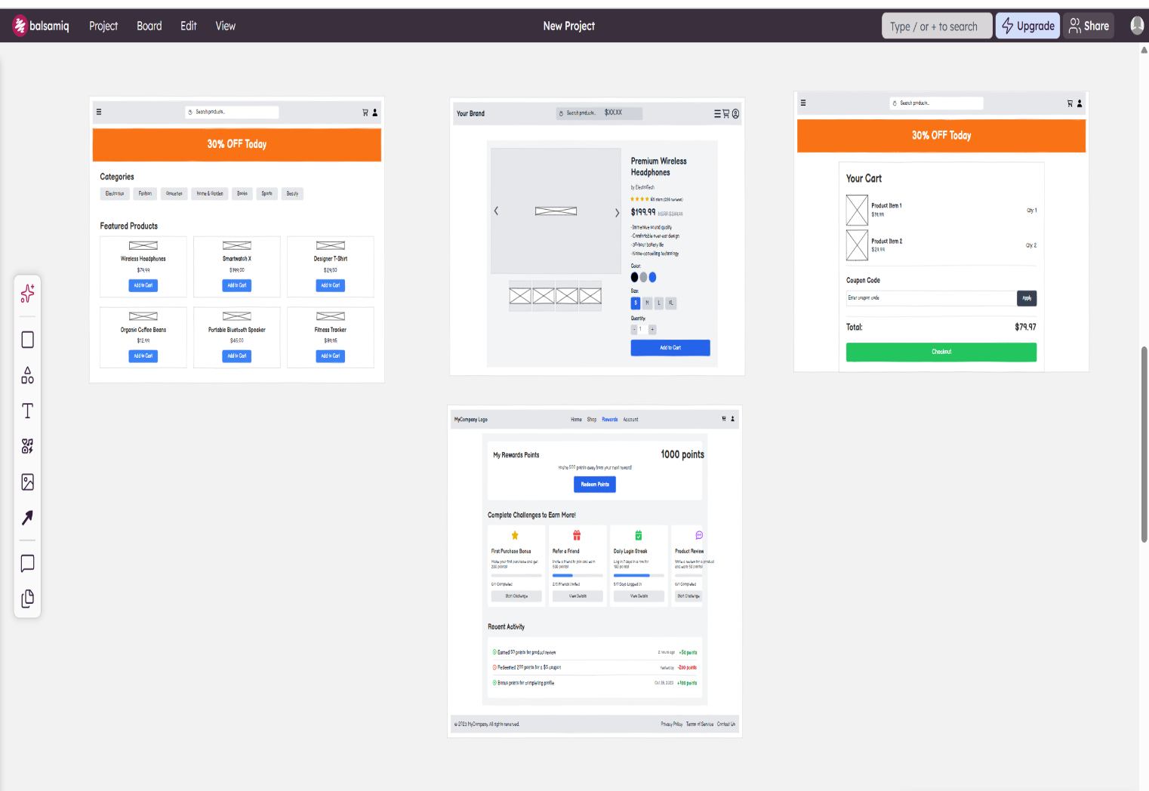
This wireframe represents a low-fidelity design of an e-commerce shopping application created using Balsamiq. It illustrates the complete user journey, starting from browsing products to completing a purchase and engaging with rewards. The home screen provides a search bar, promotional banner, product categories, and featured items, making it easy for users to explore products. The product details screen offers in-depth information such as images, price, ratings, and selectable options, helping users make informed decisions. The cart screen displays selected items, allows users to apply coupon codes, and shows the total cost before checkout, ensuring transparency in the purchasing process. Additionally, the rewards screen introduces a gamification element by displaying points, challenges, and recent activities, encouraging user engagement and repeat usage. Overall, the wireframe focuses on a clean layout, intuitive navigation, and essential functionalities required for a seamless online shopping experience.
Key Elements:
- Search bar → helps users find products
- Banner → “30% OFF Today” (promotions)
- Categories → Electronics, Fashion, etc.
- Featured Products → grid layout with “Add to Cart”
- Product image (with multiple thumbnails)

- Product name + price

- Ratings

- Options (color, size)

- Quantity selector

- List of selected items

- Quantity of each product

- Coupon code input

- Total price calculation

Prototype link:
https://balsamiq.cloud/sx5ptm9/pkwn4yi

